Reflections on Trends in eLearning
Introduction and Background:
I discovered that The Trends module challenged my current teaching practice more fundamentally than prior modules. I suspect this was because of the opening up of new ideas that emerged from my unearthing of emerging trends. The recommended readings helped me to conceptualise the overall eLearning environment, how rapidly emergent technologies were changing and challenging teaching practice. My reading of “The Tower and the Cloud” (Katz, R, N. 2008) helped me to hypothesize how these changes were directly influencing teaching practice, and how they would impact on my own practice. The five weeks of the module proceeded at a very rapid pace as new topics on emergent technologies and their influence on teaching and learning were presented.
Views and Opinions:
When I did my background reading on the modules comprising the Masters in applied eLearning, both Trends in eLearning and Supporting Virtual Communities were the modules that sufficiently kindled my interest to convince me to apply. But conversely I also found them the most difficult, when I pondered this, I came to the deduction that I had absolutely no experience in the subject matter and found it challenging to keep up with the fast pace of delivery and to conceptualise how these new concepts would possibly fit into my teaching practice. But fortunately as I came to reflect back on the contents of the module it became a lot clearer how I could integrate some of these emerging trends into my teaching practice.
It has been proposed by Co Wicklow VEC that I teach basic electronics in addition to Maths to our students in the academic year 2012-2013, and reflecting back I believe that was one of the reasons I selected mScience for my presentation, I was of the opinion that the research I carried out for the presentation could help me to present the new electronics module in a more engaging manner and would help me to incorporate pedagogical pertinent practices into my teaching practice for the new module. I especially enjoyed the area of mobile learning and the impact of this technology on learning and also the subject of game based learning. I enjoyed the freedom of being able to select a topic for my presentation that I had a personal interest in and had some background knowledge off (mLearning). The module layout was prepared so that each week, we were introduced to a new theme which built on the previous theme, this process built up the body of knowledge required for selecting and researching for our presentation.
Week 1 VLEs (Virtual Learning Environments) and The Horizon Report:
The first session provided a general overview of current trends and potential future trends in eLearning. The NMC (New Media Consortium. 2012) is an international community of experts in educational technology whose publication the annual Horizon Report, attempts to anticipate key trends over the short, medium and long term. The 2012 Report examines Mobile apps, Tablet computing, Game-Based Learning, Learning Analytics, Gesture-Based Computing and the Internet of Things. We also examined the Gartner "Hype Cycle" graphic (Gartner Hype Cycle for Education, 2011) on IT trends in education. As the saying goes a picture paints a thousand words, and I found that in graphical format I could understand the lifecycle of concepts from mainstream to adoption as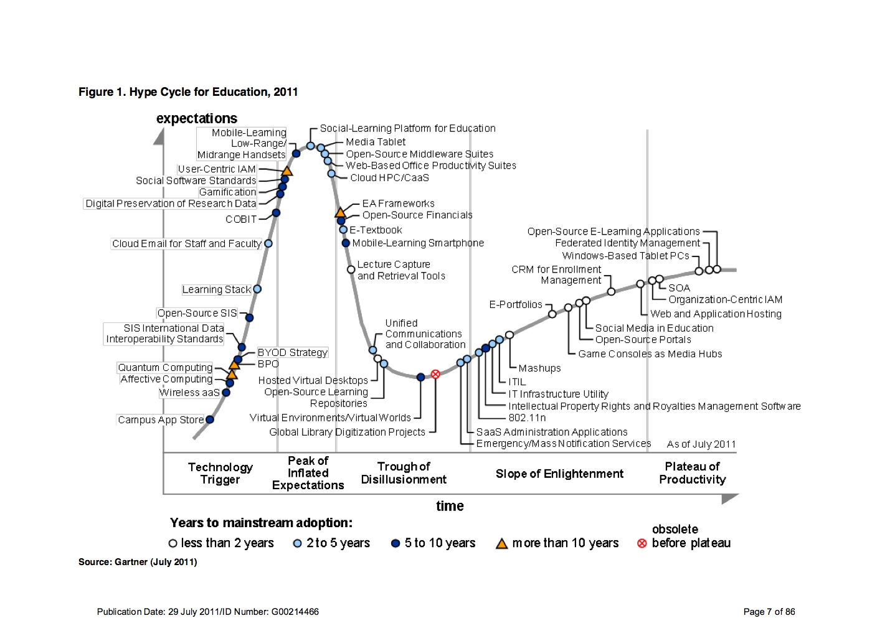
the graph evaluates the maturity of technologies and trends in education.
In the first week we also discussed the role of VLEs (Virtual Learning Environments) in higher education. As regards VLE’s what is especially important in an on-line environment is the student’s perception of their environment rather than its objective reality that impacts on learning. Steinbronn and Merideth (2003) add that self-efficacy supplies motivation to persist and, since motivation enhances problem solving, it influences later success. “When applying the concept to online teaching and learning they emphasise the need to design online support that should positively impact the psychological and physical environment of teaching and learning in an electronic area and influence the retention rate of students.”(Steinbronn, P.E., and Merideth, E, M. 2003). The discussion on VLE’s was thought-provoking and from it my appreciation grew that VLE’s are not neutral but like any technology they embed underlying values about teaching and learning, promote certain affordances and reduce other choices. (Salmon, G. 2002). The concept of affordance, according to (Salmon, G. 2002) means the properties of a system which allow certain actions to be performed and which encourage specific types of behaviour. Pertaining to VLE’s, an individual’s perceived self-efficacy, according to Houghton, Neck, & Manz. “will affect whether they are successful in performing a task.” “They state that individuals who believe in their ability to complete a given task exert more effort and persist longer, thereby sustaining performance levels until success is achieved”. (Houghton, J, D. Neck, C, P. and Manz, C, C. 2003). The supports, advice and scaffolding available from fellow learners in a team setting are invaluable in an on-line environment and the lack of availability of these supports can undermine a learners self-efficacy. I do not see a direct role for VLE’s in my current teaching practice, but I envisage a future role with the establishment of blended learning courses as a result of a Co WVEC initiative to offer retraining courses in Green Technologies and ICT to unemployed people.
The Horizon report
The Horizon report, I read the whole report but for the purpose of my presentation, I decided to concentrate on two areas within the report, namely Mobile Apps and Tablet Computing. I used some of the information on Game Based Learning for the discussion document for week three. (Appendix 1). The Horizon Report on mobile apps (NMC. 2012) examines some projects and explores how mobile applications are being used in various universities. The number and variety of apps is astonishing and I could envisage how apps could be used to enhance prior learning, with mobile apps enabling the provision of pre course materials, facilitating the development of platforms which allow students readily accessible information and pre course activities and subject materials, enhancing placement and improving successful outcomes. The flexibility and versatility of apps is a major advantage for their use in an mScience environment allowing essential programs and information to be down loaded in remote locations. Of immediate interest to me was the role of apps in teaching and learning Maths, specific apps that are used for integrating apps into Maths teaching are MyCalculator, Wolfram Alpha, Math Terms, and Instapaper (Fuhrman, T. 2012).
The Horizon Report section on Tablet computing highlighted how quickly tablets were becoming established as the preferred device for computing in the field. This was constructive information as it deliberated over the advantages of tablet computers, namely that Tablet computers have many of the features and functionality that makes them ideal instruments in an mScience setting. They incorporate many of the utilities of a laptop but with greater portability. (NMC. 2012). There versatility is further boosted as some models have the option of using solar power where no mains electricity is available. Using tablets with specific pre- loaded programs such as “MathsCasts” (Open source narrated screen video recordings explaining mathematical concepts) would be ideal teaching and learning resource for my current practice, with this in mind I have downloaded MathsCasts to my laptop and will use this program via an overhead projector for new students, starting this September.
Week 2: mLearning:
The discussion this week has been about mobile devices and their function as tools for learning; it was at this stage that I considered this as a possible subject for my presentation. The main readings I inspected were “A Mobile Science Index for Development”, Canessa, E. and Zennaro, M. 2012, and “mScience, Sensing, Computing and Dissemination”, Canessa, E. and Zennaro, M. 2010. It was these articles that shaped my intention of forming a presentation on the topic of mobile learning and mobile science and its impact on change in developing countries.
The article “A Mobile Science Index for Development”, investigated the concept of creating a barometer to be used as a measuring device to measure the potential and capacity of a community to engage in scientific tasks using mobile devices as the primary method of sensing, interpreting, storing, developing and communicating knowledge. It is the level of growth in mobile phone usage that has opened up the possibilities of using them as a platform for scientific and health related research. This article investigates at what level of penetration of mobile phone usage it is viable to use them as vehicle for sensing, interpreting, storing, developing and communicating knowledge. What also caught my attention is how current media attention has highlighted the use of smartphones and social media to be at the heart of many current social, economic, and political changes, it has been reported that the use of social networking sites such as Facebook and twitter have helped in the organisation and spread of the political and social unrest at the heart of the Arab spring.
The publication “mScience, Sensing, Computing and Dissemination” studies, some of the unparalleled technological developments taking place in information and communications technologies and how this is accelerating the uses and possibilities attainable within mScience. Some examples of how mScience can be harnessed is given in page four of the article “These include helping to prevent disease outbreaks, (Costa, A. 2009), and tracking agricultural stock levels. Data gathering with mobile devices can help to save time and money for organizations while also improving the accuracy of information pertinent to developmental issues. It is further emphasised that the more time-critical the information, for example a health related alarm in a remote area, where fast feedback is a decisive factor, the more there is to be gained by the use of mobile solutions(Canessa, E. Zennaro, M. 2010).
Week 3: Serious games and virtual worlds
Most of my readings in week three was centred on “Moving Learning Games Forward” (Klopfer, E. Osterweil, S. and Salen, K.) and Game-Based Learning in the Horizon Report. Initially I found the applications that are possible in game based learning hard to comprehend. My experience with games up to that point was watching my son spend endless hours playing “Grand Theft Auto” accompanied by loud music and narration that used plenty of strong language. The constant battles to get him to do his homework did not create an opinion that games could be useful in learning. Of all the areas covered in Trends, I was most sceptical about Game Based Learning that is why now I am so surprised at my complete conversion. Before studying or having an understanding of game based learning I was dismissive that it had much of a role in my teaching practice, but after some contemplation and research, I can now definitely see a role for Game Based Learning in teaching Maths and Electronics. PCB (Printed circuit board) wizard is a game I am researching for use when teaching basic electronics, the game simulates the flow of electrons through the circuit and through components, therefore giving the student a visual demonstration of concepts such as amplification, filtering, rectification, and changes in waveforms. By selecting different options the student can reverse these processes, modify and add different characteristics. It is hoped that this type of game play and visual representation will assist in learning electronic principles that are often difficult for a novice to electronics to grasp.
In terms of trends in eLearning, I am convinced of how worthwhile games in education can be but I thought the timeline for integration was vague; this is perhaps understandable given the major hurdles that lie in the path of implementation. I include some games when teaching Maths, I specifically tailor them to add curiosity to a subject area, for example the game “Battleships” helps to conceptualise the co-ordinated plane when teaching co-ordinate geometry, and I also include some 3-D graphic software to help in the understanding of area and volume of cylinders in geometry.
Moving Learning Games Forward also provided me with ideas to use in the future, the following methods could be used to make maths more relevant and interesting in my own practice, for example, in Palmagotchi the virtual pets are birds living in a Darwinian Galapagos, and to keep the birds alive and thriving, players must learn about ecology, evolution, and genetics. I could see similar in approaches in Maths, looking at climate change, examine percentages by looking at % of CO\2 in the atmosphere, temperature change could help introduce ratios, as in the ratio of ice/water, while Fractions could be taught by examining areas of countries that may disappear underwater.

Week 4: Is Google Making us Stupid?
I found this genuinely interesting and well written article very thought provoking. The article points to a change in the way we process information and that this leads to a change in the very way we think, Carr argues that we are losing the ability to immerse ourselves in long scholarly readings as we are losing the ability to exclusively concentrate on the one train of thought. My attention was taken by the question how much does the Instrument affect the Idiom? Reference was made to how the change from handwriting to using a typewriter had changed the style of writing of the writer and philosopher Friedrich Nietzsche, it was observed that his already terse prose had become even tighter, more telegraphic, (Carr, N. 2008) Nietzsche, replied “our writing equipment takes part in the forming of our thoughts.” (Carr, N. 2008.)
The article refers to how the introduction of the concept of time and the mechanical clock, eventually changed how people perceived themselves in the world and their relationship with nature. We moved away from direct connections with the natural world, the lives of most people living in a rural agrarian economy were synchronised with the seasons, a time to plant, a time to grow, a time to harvest and a time to store. Following on from this observation Carr skilfully draws a parallel with current trends and argues that the internet is changing how people interact with wider world and is changing the way people think.
He argues that deep reading and thought which used to come naturally to him when immersed in a book is no longer possible, that something like an attention deficit disorder is developing with a lack of ability to concentrate for more than 15 minute bursts, Carr maintains that media in general and the specifically the internet are not just passive channels of information but that they actually alter our cognitive processes and supply and shape our very thoughts lessening our to capability for concentration and contemplation. That because of the vast amount of instantaneous information available to us married to the visual nature of the internet with its easy to get side-lined hyperlinks, flashing and pop-up ads both affect concentration and is not conductive to deep reading and contemplation. Much of the textual information available on the internet is in short articles and summaries the success of this format has seen it being adopted in other media such as TV, magazines and newspapers.
In reflection to my own teaching practice I am aware of the short attention span presented by many students, most of who could be categorised as digital natives. Further information regarding reading habits was gathered using an induction level literacy survey, over 80% of those questioned, responded that they had never read an article of more than 3 pages in length. Reading this article and further reading of the book “The Shallows” by the same author have promoted me to question the style and manner of some teaching materials I use, and to enquire if radical design and layout changes may be needed to make this more effective learning material.
Week 5: Presentation
There was a wide variety of topics covered, fourteen in total, the peer-review session was very instructive and I was astonished by the quality, creativity, variety and the wide area of expertise displayed. I could see shortfalls in my own presentation, it was too long, to text orientated, and significantly needed referencing tightened up. With this on board I fully reviewed my presentation, put in extra work required on pictures and images, improved the layout, endeavoured to create a clearer focus and structure and tried to create a more logical flow with less text. I also undertook to provide an overview and conclusion.
Conclusion:
My presentation was centred on the area of mobile learning in the developing world; it also considered how mobile devices can be used as scientific instruments for the sensing, computing and dissemination of scientific knowledge. I am content I selected this particular area, as I have a background in Electronics, having spent over twenty five years working in the Electronics industry, and I wanted to research an area I had some knowledge of and interest in. I have also travelled to quite a few developing countries and this furthermore fuelled my interest. I was encouraged by the response of my peers to my presentation, although it certainly would have been one of the more conservative demonstrations and in my opinion lacked some of the more professional features of the presentations displayed.
References:
Canessa, E. & Zennaro, M. 2012. “A Mobile Science Index for Development”, International Centre for Theoretical Physics (ICTP), iJIM – Volume 6, Issue 1, January 2012. Trieste, Italy
Canessa, E. & Zennaro, M. 2010. m-Science, Sensing, Computing and Dissemination, ICTP, Italy. Publisher ICTP—The Abdus Salam International Centre for Theoretical Physics 2010 ICTP Science Dissemination Unit, e-mail: sdu@ictp.it. Printing history: November 2010, First Edition ISBN 92-95003-43-8
Carr, N, (2010). “The Shallows”. Atlantic Books, London.
Carr, R. 2008. Is Google Making Us Stupid? The Atlantic MAGAZINE JULY 2008. “What the Internet is doing to our brains”
Costa, A. 2009. State Health Secretary of Amazonas State. Brazil
EPROM. 2009. Entrepreneurial Programming and Research on Mobiles of the MIT- Massachusetts Institute of Technology, (2009) <http://eprom.mit.edu/whyafrica.html>.
Foreman, R. 2008 THE PANCAKE PEOPLE, OR, "THE GODS ARE POUNDING MY HEAD" [3.8.05] The New York Times Company, 620 Eighth Avenue, New York, NY 10018
Gartner Hype Cycle for Education. 2011, Publication Date: 29 July 2011/ ID Number G00214466
Gunter, B. Rowland’s, I. Nicholas, D. 2009. Is there a Google Generation? Information Search Behaviour Developments and the Future Learner. Oxford: Chandos Publishing Ltd. ISBN: 1843345579.
Houghton, J.D. Neck, C.P & Manz, C, C. 2003. We think we can, we think we can, we think we can: The impact of thinking patterns and self-efficacy on work team sustainability. Team Performance Management: An International Journal 9, no’s 1–2: 31–41.
iJIM – Volume 6, Issue 1, January 2012
Katz,N,R. 2008. “The Tower and the Cloud, Higher Education in the Age of Cloud Computing”. EDUCAUSE
Klopfer, E., Osterweil, S. & Salen, K. 2009. Moving Learning Games Forward. Obstacles, Opportunities and Openness. The Education Arcade, Massachusetts Institute of Technology
Kolb, D.A. 1984: Experiential learning: experience as the source of learning and development. Englewood Cliffs, NJ: Prentice Hall.
Mathcasts. Creative Commons Licence (2012). Accessed July 2012 www.mathscasts.org/find_a_mathscast.html
NMC Horizon Report: 2012 Higher Education Edition
Salmon, G. 2002. Warp speed or snail’s pace? Pathways into the future of E-learning land. Keynote presented at the Second National Virtual Learning Conference, June 24, in Bristol, UK.
Steinbronn, P.E., & Merideth, E, M. 2003. An outward design support system to increase self-efficacy in online teaching and learning. Campus-Wide Information Systems 20, no. 1: 17–24.
Vest, C. 2008. “On-Demand Computing: A brutal Slog,” Business Week, July 18, 2008.

Appendix
Sample taken from discussion post on gaming:
Reading the following example got me thinking about methods to make maths more relevant and interesting for my own practice, it starts off with:
Tamagotchi virtual pets, which are very simple games played for seconds or minutes at time over long durations. Educational games can emulate this style of play. Teachers no longer need to use class time to play games, but instead can use the class time to talk about data coming from the games outside of class. EG: in Palmagotchi the virtual pets are birds living in a Darwinian Galapagos, and to keep the birds alive and thriving, players must learn about ecology, evolution, and genetics. I could see similar in approaches in Maths, looking at climate change, examine percentages by looking at % of CO\2 in the atmosphere, temperature change could help introduce ratios, as in the ratio of ice/water, while Fractions could be taught by examining areas of countries that may disappear underwater.

