Material Removed 21/08/15

Record (2005) has explored the need for the development and deployment of virtual learning environments (VLE’s), which provide adequate training in developing the art of fault finding on a variety of electronic circuits for first year electronic undergraduate Students. What were his findings?
+ 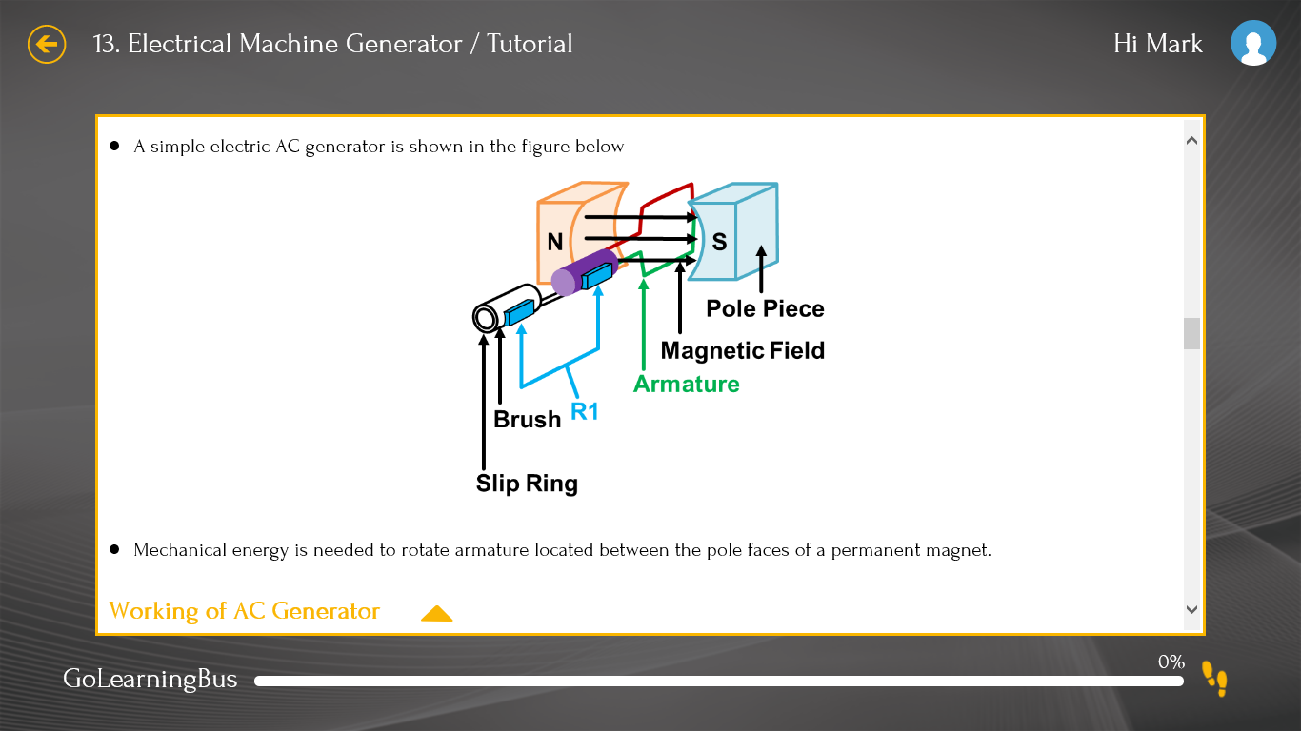
Figure 6: eLearning Resource: a 3-dimensional cut-out explains the working of AC Generator

Figure 8: eLearning Resource: The Electronics Quiz

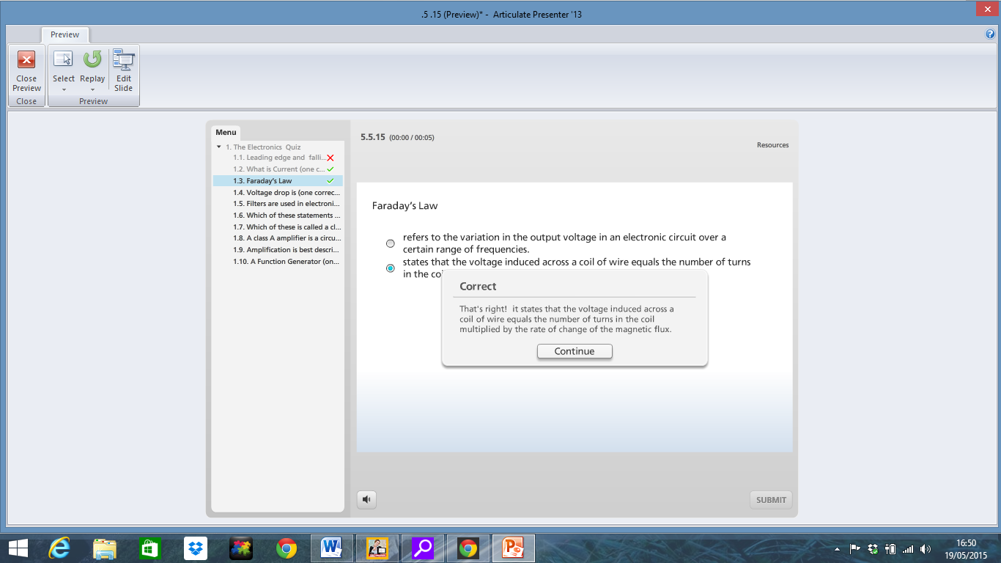

Figure 9: eLearning Resource: The Electronics Quiz

Further reading argued that a more rigorous design and development approach makes sense in certain circumstances, such as when learners must be able to perform critical skills with great accuracy Gagne, (2005). Deleted from P15

The degree of control the students had with navigation throughout the app, was in the researcher’s opinion an area that could have been refined; this came through as part of the usability evaluation carried out by an experienced instructional designer who observed that a main menu would have simplified navigation and resulted in a better interface by providing a linear menu structure with links to each module. The students had already used and evaluated the eResource by this stage and did not mention this as a barrier to their learning, nor did the teacher observe this as an issue. Mark – . Mark - Discuss this point in relation to literature here. Deleted from P21

There is some difficulty in quantifying this clearly because initially the students were already immersed in developing this skill on their programme, and in acquiring a threshold concept, it is difficult to precisely calculate how much extra learning the eResource contributed. Deleted from P24
The authors observe that younger students face greater challenges because their visualization and cognitive capabilities are in a formative stage. Deleted from P6

For the renewable energy sector, the Forfas (2010) report “Future Skills Needs of Enterprise within the Green Economy in Ireland” highlighted the current and future need for Electrical/Electronic engineers and technicians to oversee the development of the electricity grid into a ‘smart distribution network’, using a combination of electrical engineering and ICT skills. Deleted from P4

Throughout the design of an eResource incorporating multimedia tools, the researcher or designer must be conscious of the processing capabilities of the learner. Knowledge and instruction whether using multimedia or not must be planned to support the internal processes of learning. Gagne (2005, page no’s) summarised that “the events of instruction are designed to activate the processes of information processing, or at least to parallel their occurrence and support the process.” Deleted from P22

Novice learners need to learn and practice new skills, the eResource is designed to motivate and improve performance by providing an opportunity for learners to confirm their correct understanding of electrical and electronic principles by using tutorials, flashcards and quizzes; repetition further increases the likelihood of retention with the goal of achieving domain knowledge. Deleted from P12

