Does an eLearning resource with mobile apps improve student learning in Basic Electronics, Electricity and Maths?
Mark Maguire
Abstract
Novice learners of electronics, electrical principles and the mathematical theory inherent in each can face obstacles with attaining the threshold concepts involved. To help explore the academic potential of an eLearning resource containing mobile apps in these electronic technology fields, the study first examined if there was a need for an introductory online resource designed to support the novice learner in acquiring domain knowledge in electronics, and then investigated trends relating to opportunities in Green Technologies. The control and communication systems integral to many Green Technologies are dependent for their design, installation, maintenance and efficient running on knowledge of Electronic Technologies. Analysis of empirical evidence collected from twelve, 1st year Electronic students at Dun Laoghaire College of Further Education reported benefits from using the introductory eLearning resource, specifically that certain threshold concepts which they as novices in these fields found difficult to grasp, were understood with greater ease and in increased depth.

Article Info
Article history:

Keywords:
●Active learning ●Electronics
●Green Technology
●Mobile Apps ●Multimedia ●Reusable Learning Objects

1. Introduction
To comprehend the impetus for this research, it is essential to understand the unique research context involved (Cousin, 2009), the history and positionality of the researcher (Foreman-Peck & Winch, 2010; Thomas, 2013) and how these combined to ignite the research aim (Ezer, 2009). The specific research question grew organically out of a cross-section of influences and was targeted toward a pressing practical problem (Huczynski, 2004), experienced by students in further education 1st year courses in maths and electronics. A cursory investigation of popular app stores shows that the use of mobile apps in the technical training sphere has proliferated in recent years. The aim of this research was twofold; firstly to explore if an eLearning resource, integrating mobile apps, was needed by learners to deepen their understanding of basic concepts in electronics, electricity and maths. Secondly, the study reviewed career opportunities in Green Technologies for Electronic Technicians (National Skills Bulletin, 2014. Behan, J. McNaboe, J. Shally, C. Burke, N.). The researcher has over 25 years work experience in the electronics field, an area which is currently having an extensive impact on employment and economic opportunities. Case studies and forecasts highlighting these developments are pointing to increasing opportunities for employment for people with a background in Electronics (National Skills Bulletin 2014, p.84). Electronics has become an integral element throughout most walks of life, with its footprint becoming virtually all encompassing, and the need for skilled electronic engineers and technicians to work in a multitude of platforms both nationally and internationally has never been greater (National Skills Bulletin, 2014, p.71). As a result of this, there is a need for quality training and instruction in these fields, and there have been calls in both the commercial and academics literatures for a solution. Wag Mobile Inc. (2014) and Delimarsky (2011) have set out the need for a user-friendly learning resource, integrating up-to-date apps, especially designed for the novice learner, available on multiple platforms and giving 24 hour access, to provide new Electronic technicians with a flexible training and instruction tool to use as their needs determine.
Given the large range of the industry, this study also focused on the potential of Green Technologies and its associated technical requirements, such as knowledge of measurement and control systems and power engineering, as they are likely to have an impact on future employment opportunities for these students. There is a bewildering range of educational apps available with wide variations in the quality of the instruction and training on offer; the study initially examined many on offer in the electronic training field, eventually focusing on two apps which concentrated on elementary electronic and electrical material presented in a clear and concise format as being the best fit for the novice 1st year Electronic students.
The objectives of this study were to validate that the content of the eLearning resource offered the potential for deeper learning in these subjects, and to investigate prospects for the same students to pursue study in related Green technologies. Data was collected using a needs analysis, a semi structured questionnaire and a focus group interview, with 12 students and an instructional designer participating in the study. A case study approach was used to explore the rationale for the eLearning resource, and investigate the best structure and strategies for learning online to achieve the most beneficial outcomes for in-depth student learning in these fields.
1.1 Context and Rationale
Research was carried out at Dun Laoghaire College of Further Education, in co-operation with 1st year students studying Fetac level 5 modules in Electronic Technology and Sound Production. To better support these new 1st year students of electronics, an eLearning resource was designed to provide them with the basic maths, electronic and electric skills required in their programme. This study contributes to the discipline of technology in education by establishing how mobile apps can be effectively combined into an online learning resource to produce a flexible and authentic tool for 1st years. Learning electronics and electrical skills for the beginner can be a challenging task, especially having to come to grips with a new technology that has its own terminology, rules, symbols and principles (Mulder, Lazonder & de Jong, 2010, p.2034). Knowledge and the ability to use these skills to an advanced level are of paramount importance for many technology roles in industry. The manner in which students perform these processes is dependent on their knowledge of the task domain. Students with domain expertise can use their prior knowledge to create premises and propositions on a topic, but as Mulder, Lazonder & de Jong (2010, pp.2035-2036) argue, “Students without domain expertise cannot generate initial hypotheses from prior knowledge”. In the same vein, Stevens, Gerber & Hendra (2010) contend, “As students identify and organize principles and processes associated with the prior learning area, the narratives gain depth and richness, improving domain knowledge in their subject area, especially when analysed in light of relevant theory”. The Adaptive Character of Thought (ACT-R) theory has an influence on this study – it was put forward by Anderson (1996, p.355) who argues that “complex cognition arises from an interaction of procedural and declarative knowledge”. This theoretical underpinning and its relevance for this study is further explored in the literature review.
Further justification for the need for the study is provided by recent research. The most current TIMSS report (Trends in International Mathematics and Science Study) (Eivers & Clerkin, 2011) from the Educational Research Centre, indicates weakness in the abilities of Irish post primary students (school leavers) in their mastery of Maths and Science. TIMSS are large international comparative studies of achievement that assess respectively, the reading, mathematics and science skills of primary and post-primary school pupils. Although Ireland’s mean score of 527 is above the TIMSS mathematics centre point of 500, Ireland is in 17th position in the TIMSS mathematics table (2011). Irish pupils were significantly outperformed by pupils in 13 countries, including Northern Ireland, Finland, England and the U.S. Ireland’s mean score for TIMSS mathematics does not differ significantly from the means for Lithuania, Portugal and Germany, and is significantly higher than the mean for 33 countries, including Australia, Italy and Sweden. Ireland’s main trading partners and its greatest source of direct foreign investment in provision of jobs and services come from the same countries that significantly outperformed it based on the most recent TIMSS report; arguably this divide in students’ performance in Maths and Science needs the provision of relevant educational resources to bridge the knowledge gap.
Further research was conducted in 2009 (Ireland did not participate in the ‎‎2013 survey) by TALIS, the Teaching and Learning International Survey, a project of the Organisation for Economic Cooperation and Development (OECD). TALIS focuses on the learning environments and teaching conditions in post-primary schools (OECD, 2009). Irish Principal Teachers in TALIS were asked to identify resource issues that hindered instruction. Eighty-three per cent of teachers in Ireland (the highest percentage amongst TALIS countries) taught in schools whose principals reported that a shortage of laboratory technicians hindered instruction ‘a lot’ or ‘to some extent’, affecting the teaching of science (OECD (TALIS, 2009, p.3).
The Electronic/Green Technology sector of the economy is one which is arguably changing, growing and developing more rapidly than any other sector, and there are strong global and domestic drivers transforming it. A variety of different forecasts are pointing to increasing employment opportunities for people with Electronics background in the field of Green Technologies (National Skills Bulletin, 2014, p.62). Within the National Skills Bulletin report (2014) by the Expert Group on Future Skills Needs, some 33% of companies researched had skills gaps, reporting shortages of trained technical personnel mostly arising as a result of continuous technical innovation, development and change. Over the period 2012-2020, well above average growth is projected for this occupational group (Further Education and Training Strategy 2014-2019). SOLAS/SMLRU Employment Forecast 2020’ Report (2014).
Harnessing the field of mobile apps allows for the convergence and development of new platforms to deliver training and instruction, permitting the tracking of web, mobile and social traffic Moore (2011). By combining an eResource with embedded apps, a real educational need in further education can be addressed, by helping to overcome gaps in students’ knowledge of maths, basic electronic and electrical principles as outlined in the TIMSS report. The research undertaken demonstrated the need to develop task domain knowledge in technical subjects using pedagogically relevant resources; this had been discussed by Mulder, Lazonder & de Jong (2010), who recommended the provision of introductory online resources designed to stimulate proficiency in students. Growing shortages of trained technicians and engineers as outlined in the “Expert Group on Future Skills Needs” accompanied by an increased number of further education technical programmes aligns with the report of the “Further Education and Training Strategy” (2014-2019), (Solas, 13th May, 2015); A Strategy for Growth (2014-2020 P.45).
2. Literature Review
The preliminary focus of the study was to build a case for how an eLearning resource combining apps could improve student learning in a 1st year further education context. The literature consulted included textbooks, conference papers and journal articles on the topics of how to improve domain knowledge in technical subjects and the use of eLearning for supporting 1st year students. The requirements for 1st year students in the Further Education programme to have a comprehensive glossary of electronics and electrical terms and information on scientific notation guided some of the early research for the eLearning resource. Initial reading for the study was broad based, concentrating on the basics of electronics and electrical systems.
Information from TALIS (Teaching and Learning International Survey), TIMSS (Trends in International Mathematics and Science Study), and the Expert Group on Future Skills Needs and Forfas, were the main source of data on specific areas of 1st year student weakness in maths, electronic and electrical principles, while also providing information on future job opportunities in the Green Technology sector for electronic technicians.
A questionnaire and a focus group interview with twelve Fetac level 5 students studying modules in Electronic Technology and Sound Production at Dun Laoghaire College of Further Education, provided insightful findings and helped to direct the literature research to the areas of novice learning and the need to develop domain expertise to address weaknesses in specific areas in basic electronic and electrical principles, especially threshold concepts and how the use of active learning strategies can benefit students. In the subsequent sections of the literature review, screenshots from the eResource developed have been included to illustrate the design concept being discussed.
2.1 Novice Learners and Acquiring Domain Knowledge
The skills, knowledge and experience of many novice learners to electronics suffer gaps in the form of undeveloped measuring and fault-finding abilities combined with a lack of empirical thinking. This becomes apparent in their first few weeks in a laboratory setting as they are coming to grips with new terminology, components, measuring devices, circuitry, concepts, safety features and laboratory layouts. 1st year students report this can seem both bewildering and overwhelming, and this is added to by the requirement to develop independent thought and coherence in scientific thinking, as outlined in Redish, (2003.p13).
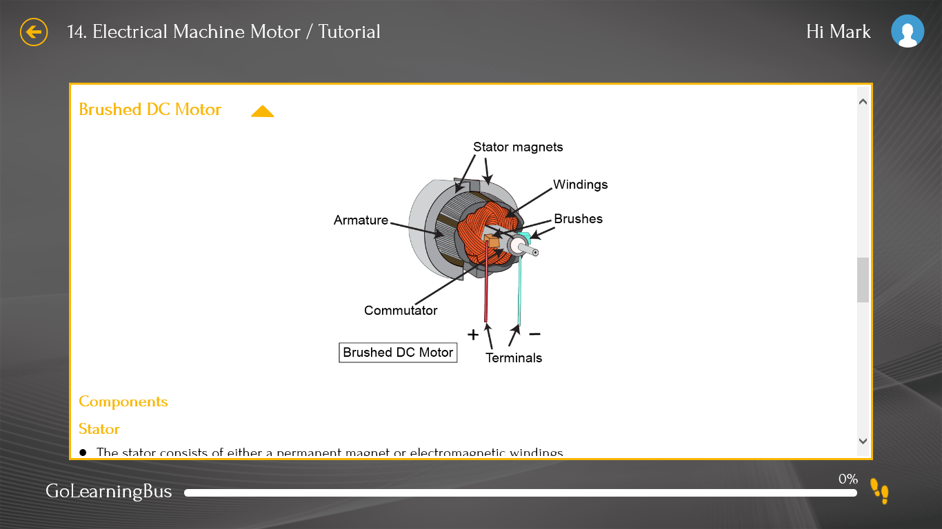
Figure 1: eLearning Resource: AC and DC Electrical Motor Theory using a 3-dimensional cut-out of the motor mechanism
Card, Mackinlay & Shneiderman (1999, p16) argue that interactive visualization tools help novice learners, especially in an abstract subject such as Electronics, by allowing the student to visually step inside a three dimensional shape creating a stronger ability to visualize abstract relationships and objects, such as current flow and voltage drop in circuits. Figure 1 above is an example of a three dimensional cut out of an electric motor allowing the student to visually step inside the motor casing, examining component size, shape, layout and assembly. The greater the level of engagement students have with these objects, the better the learning outcome, and these visualizations allow students to explore more difficult concepts. The “Wagmob”, “Electronics” and “Electrical Engineering” apps embedded in the resource incorporated these salient features allowing students to view, use, and observe changes taking place in circuit behaviour and performance.
Liang & Sedig (2010, p.973) supported the researcher’s view that exploratory interactive tools will help and encourage novices in the field of electronics and maths. 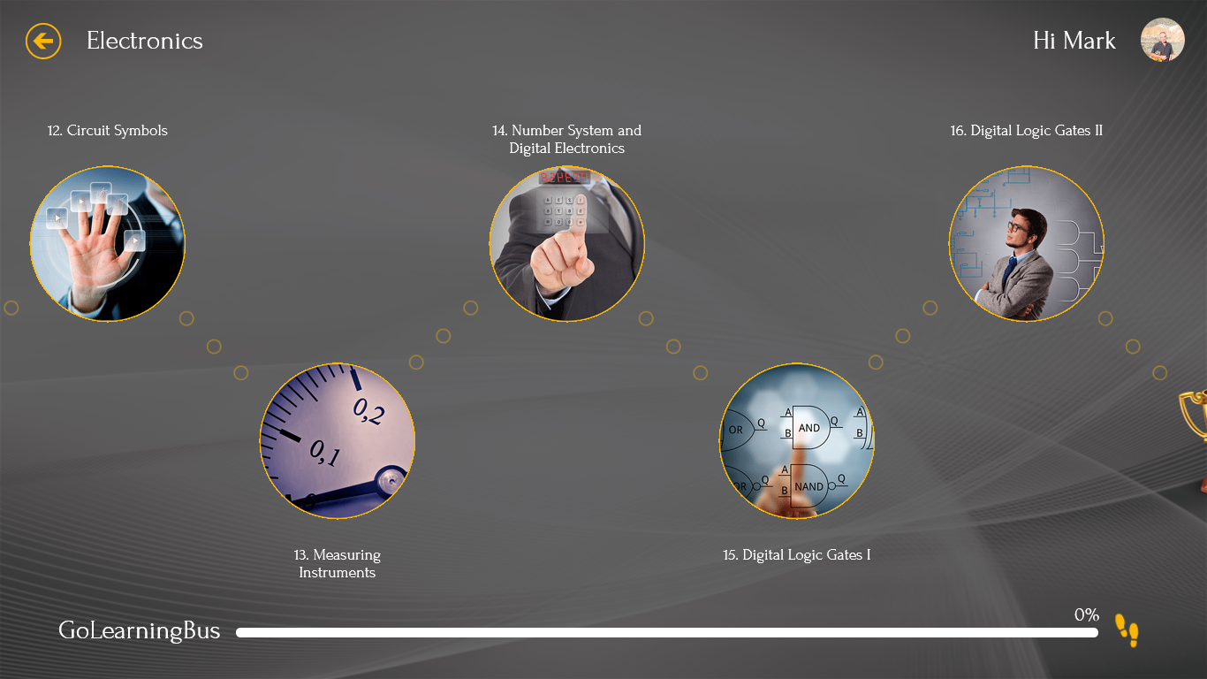
Figure 2: eLearning Resource: Screenshot of navigation window for electronics app
They provide a clear definition of interactive visualization tools as “external artefacts whose primary aim is to support and enhance users’ exploratory, interpretational, and sense-making processes involving visually-represented information.” An example is the Figure 2 screenshot above showing navigation in the electronics app from tutorial 12 through to tutorial 16. The contributions of Chen, Hong, Sung, & Chang (2011) informed the design of this current study to include Interactive visualization tools (IVT’s) in the eResource. The authors investigated the effectiveness of visualization and manipulation tools on learning, finding evidence and building a convincing case that visualization technologies have positive impacts on learning. They sought out tangible benefits of these technologies in the learning process disclosing that increasing interactions and opportunities for manipulation result in improved learning, and provide proof that “simulation based learning activities help learners to acquire knowledge through the process of observation, exploration, experiencing, and reflection.”
2.2 Learner Engagement in Threshold Concepts
Research shows that greater engagement facilitates the reinforcement of important threshold concepts. Ronen & Eliahu (2000) discuss learner engagement, taking the view that one of the most common problems faced by learners of electronics is being unable to fully understand the abstract concepts that underlie the system responses predicted by theoretical models. This often results in learners being unable to see the link between models and actual circuits.
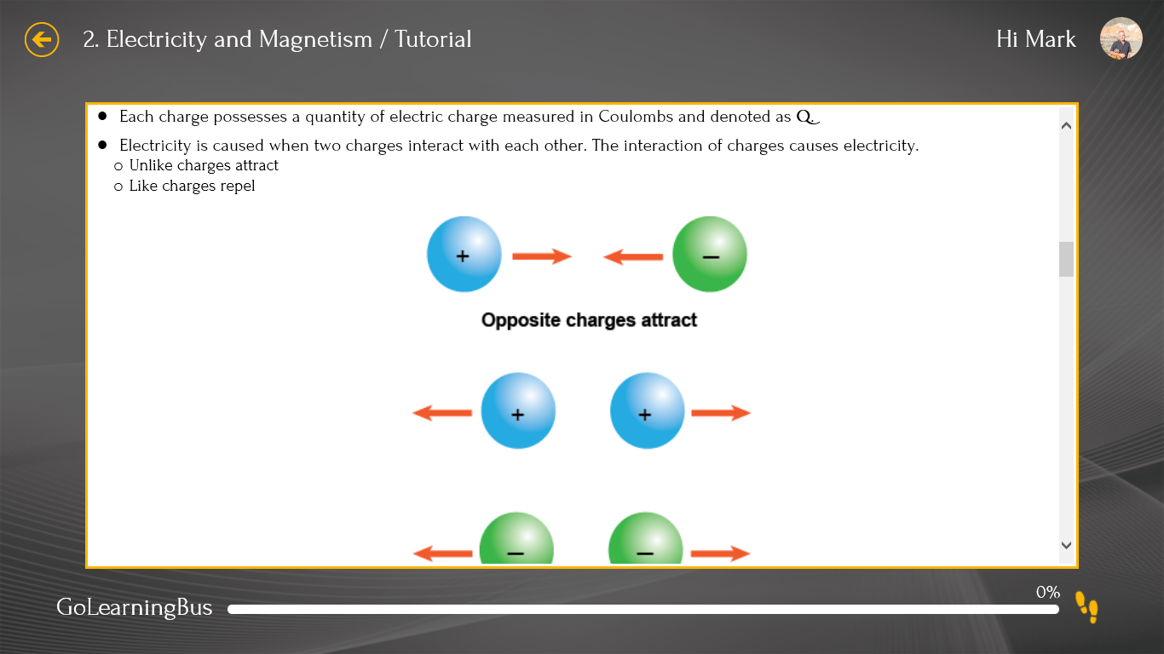
Figure 3: eLearning Resource: Electricity and Magnetism Tutorial explaining positively charged proton particles and negatively charged neutron particles
Figure 3 above, from tutorial 2, the Electronics app, provides a graphic illustration of electricity and magnetism, allowing the learner to build a bridge from abstract theory to tangible practice. Ronen & Eliahu, further explain that the traditional text book approach is unsuitable for this dynamic subject, failing to provide real-time feedback of material, and leaving learners frustrated and discouraged when they are attempting to understand complicated abstract concepts. They continue to strengthen their contention that simulated experience is better than no experience citing Ronen & Eliahu (2000, pp. 14-26) who believed that simulation has great potential as a supplementary tool, “with simulation as a medium helping learners to repair missing links between theories and actual electronics processes”.
The simulation-based learning model used in the design of the eResource contains three phases: concept learning, simulative manipulation, and concept clarification. In the concept learning stage, learners conduct electronic learning tasks by using interactive visualized pictures, texts and symbols. In the app ““Electrical Engineering” this phase is evident in the Tutorials with the emphasis on pictures and diagrams using different colours to represent components and current flow.
Figure 4: eLearning Resource: Mesh & Node Analysis are methods of determining the current and voltage between nodes in an electrical circuit.
Flashcards as illustrated in Figure 4 are used to revise and summate important points covered, helping to reinforce learning. At each concept learning stage, the student revises the flashcards and undertakes the quiz associated with the material covered. Further support for this learning practice is provided by Gordin & Pea (1995) and Ainsworth (2006, pp. 183-198) who found that “visualized simulation helps learners to achieve a higher level of cognition by facilitating their interactions with multiple external representations and reflection on phenomena, as observed when learning a given abstract concept”. Moreover, visualized learning can also motivate learners and help them to transfer concepts into long-term memory (Colaso et al., 2002; Naps et al., 2003).
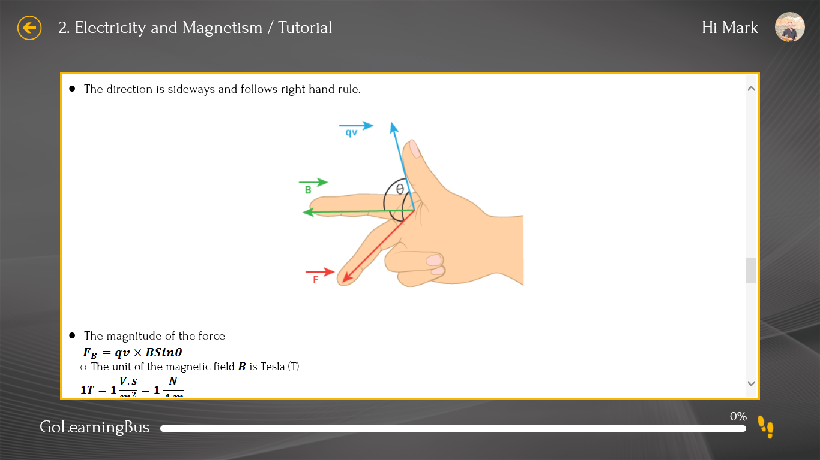
Figure 5: eLearning Resource: Electricity and Magnetism Tutorial, the direction of a magnetic field as explained by the right hand rule.
Figure 5, above, tutorial 2, the Electronics app showcases simulative manipulation helping learners to practice simulations, with the aim of guiding learners to understand complicated abstract concepts. Representations such as the resistor colour code, “Kirchhoff’s” Law, and direction of current flow are provided. Students use a virtual finger to draw the direction of the magnetic field. By manipulating the parameters, in this case the direction of a magnetic field, the student is able to observe the result. This ‘to and fro’ helps students to understand some of the difficult theoretical concepts that need to be continuously reflected over to gain a deeper understanding of electronics, and the use of the models learning-reflection learning path helps to promote this goal.
The final stage of the process is referred to as the concept clarification stage, whereupon the student fully understands how changes in the input parameters are reflected throughout the component or circuit under test, and is able to internally visualise how these changes take place and are set in motion.
2.3 Problem Recognition
Testing and fault finding is where novice students have the greatest difficulty, essentially putting theory into practice; in the current study, the findings from the questionnaire and the focus group interview confirmed this. Fault finding is divided into generating a hypothesis or supposition and then testing this supposition using a variety of diagnostic test equipment. When a student is initially asked to draw hypothesis about the nature of a fault(s) in electronic equipment, an initial consideration is problem recognition; the fault can only be accurately identified if the student is capable of systematic, logical and rigorous analysis of the features displayed by the fault.
Running a series of typical faults, learning the correct sequence of measurements and investigation, allows the student to build experience, knowledge and confidence in their fault finding abilities. Record (2005) influenced the development of the eLearning resource regarding apps that were deemed suitable as learning objects; it was essential that the apps considered were cognisant that developing skills in fault finding requires practice on real faults or simulated faults close to the real situation. This learning approach is underpinned by a theoretical rationale, and the strategy fits within the framework of adaptive character of thought (ACT) developed by Anderson (1996) at Carnegie-Mellon University.
2.4 Active Learning
Quizzes are regarded as one of the most successful methods to integrate active learning strategies for an online environment, Moore & Kearsley, (1996, pp. 200-201) argue- “Active learning is probably not going to happen in an online environment unless the interaction is deliberately planned and the instructor encourages it” Active learning requires “intellectual effort, encouraging higher order-thinking (analysis, synthesis, evaluation)” and provides a means for learners to assimilate, apply and retain learning (Bonwell & Elson, 1991, p. 3; Harasim et al., 1995). Active learning accommodates a variety of learning styles, promotes student achievement, enhances learner motivation, changes student attitudes and causes learners to learn more (Astin, 1985). The resource was designed to emphasise and promote active learning, with quizzes employed after each learning resource, figures 7 below, shows a quiz on scientific notation, widely used to specify values for electronic components and essential knowledge for 1st year electronic students.
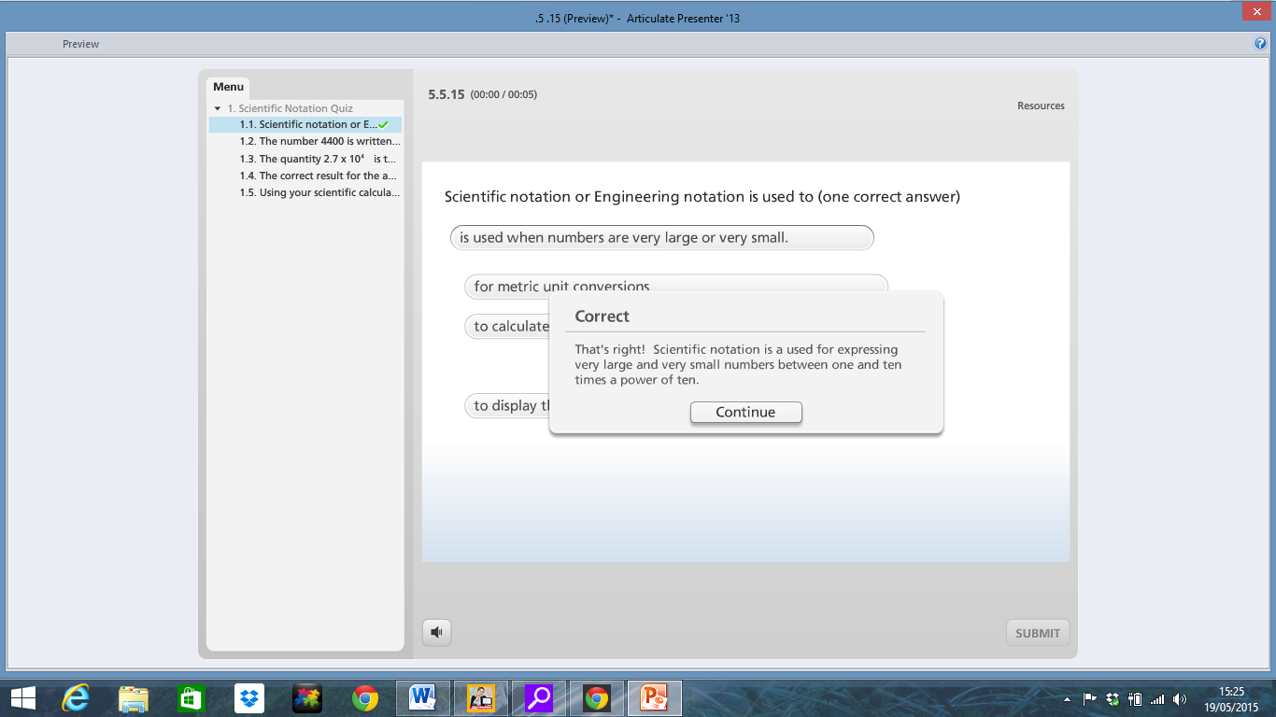
Figure 7: eLearning Resource: Scientific Notation Quiz
The literature review investigated the most relevant pedagogical methods to use for enhancing the learning experience for first year students in electronic technologies. Research emphasised that to achieve success, such novice learners must acquire domain knowledge, and the strategies that can be put in place to achieve this are active learning as a plan to reinforce learning, problem recognition to develop fault-finding skills, and learner engagement to help fathom threshold concepts.

3.0 Pedagogical Design of the Resource
A major theme that emerged from the initial focus group interview and literature review was the need for a resource to support novice learners. Supporting novice learners was achieved by maximising their engagement with the eResource, and growing their enthusiasm through the content, construction, design and layout. Using Gagne’s Nine Events of Instruction Design model (1965) promotes learner engagement by influencing the concept learning stage through stressing declarative and functioning knowledge. The simulative manipulation stage highlights practice and reinforcement, and the concept clarification stage emphasises the intuitive knowledge gained resulting from reflection and consolidation. Research has revealed that the use of colour and interactive visualization tools can help and encourage novices in the field of electronics and maths (Keller & Keller, 1993; Tufte, 1990).
Mulder, Lazonder & de Jong (2010) supported this approach in their research on the implications for supporting domain novices in inquiry learning environments. They compare students with prior subject knowledge and novices involved in conducting experiments in an electronic training laboratory; they confirmed that the effectiveness and efficiency with which students perform these processes (experiments) differed depending on the level of their domain expertise. Students with domain expertise can generate hypotheses from prior knowledge, and engage in more theory-driven experimentation which leads to superior task performance. These findings help to confirm the importance of developing prior knowledge especially in the novice learner.
Gagne’s Nine Events of Instruction (1965) was the most relevant micro model in the pedagogical design stage of this study. The following key steps were applied to the design of the eResource: Gaining attention; Informing learners of objectives; Stimulating recall of prior learning; Presenting the content; Providing ‘Learning Guidance’; Eliciting performance; Providing feedback; Assessing Performance; Enhancing retention and transfer to the job. Applying the nine-step model to any training is the single best way to ensure an effective learning programme (Gagné, 1965).

Active learning is a key element in the design of this eResource, as it has been designed to engage and actively interact with the learner through the use of multimedia, apps, Xtranormal, audio, quizzes and interactive learning objects.
eLearning resource development was influenced by the focus group findings, 1st year students indicated a lack of prior knowledge of some basic electronic and maths skills; the development of these skills necessitated the formation of declarative and functioning knowledge aided by using the glossary, apps, scientific notation and green technology content. Figure 10 below highlights the glossary in slide 4. Learning was augmented by practice and reinforcement gained through participation in the authentic tasks in the construction phase, involving revision, flashcards, quizzes, flowcharts, and truth tables. Finally intuitive knowledge resulted from reflection, consolidation and experimentation using lab work.
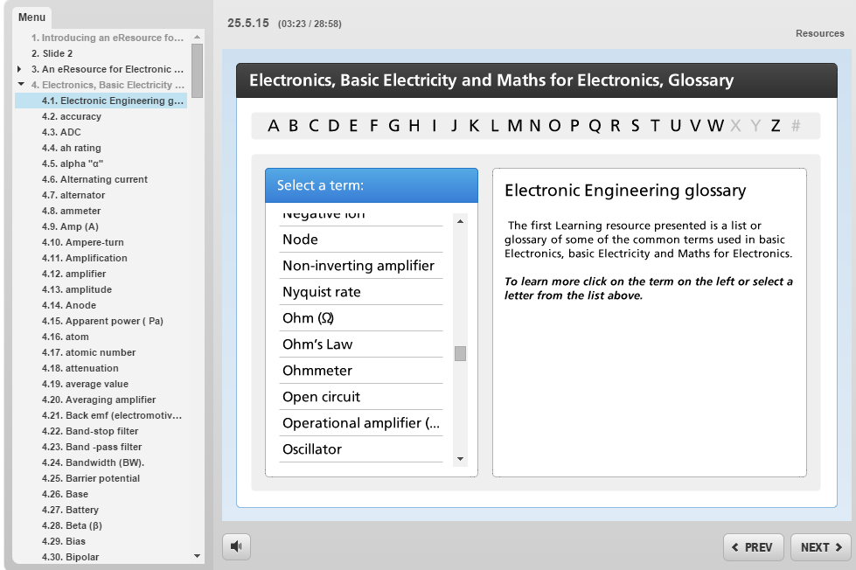
Figure 10: eLearning Resource: Electronics, Basic Electricity and Maths for Electronics Glossary

Insights for the layout and structure of the eResource was provided by Andrews & Haythornthwaite (2007, p.42) who argue that “eLearning research should always start with the pedagogy; research begins with the learning context from which the exploitation of technology can be viewed.” Many of the learners had little prior knowledge of the subject areas, so the avoidance of cognitive overload in the initial design of the eResource was an essential consideration; the layout of new materials and concepts had to be co-ordinated so as to avoid overwhelming working memory capacity. Literature explored showed the drawbacks of employing multimedia into an eLearning resource without an understanding of its influence (Gagne, 2005). Findings from Austin (2009) showed the position of text with moving and flashing objects can cause distraction, resulting in an inferior level of learning as accounted for by test performance in certain multimedia conditions. He argues that display design can split attention, increase cognitive load, and reduce transfer learning.
Shank & Bircher (2009, p15) indicated that it is appropriate to use rapid eLearning development models: “when needed content is already available or easily obtained.” Investigation revealed a multiplicity of well-designed and easy to use mobile apps for learning maths and electronics available free or for less than €1, for download on a multiplicity of platforms. Focus group findings profiled the learners as mostly novices to the field of electronics, learning non-critical applications in their 1st year; this helped to further refine the design and aim of the resource.
3.1 Colour
The “Wagmob” Electronics and Electrical Engineering apps combine colour and directional symbols helping the learner to identify the direction of current flow when learning “Kirchhoff’s” law. A resistor colour coding system is employed for the student to identify resistor colour codes and compare results, Figure 11 below. The use of colour to reinforce visualization and cognitive capabilities is described by (Keller & Keller, 1993) “Colour plays an important role in visual communication”; colour operates at both perceptual and subconscious levels and its judicious use can enhance the communicative power of visual images. This was important to be cognisant off in the eResource design.
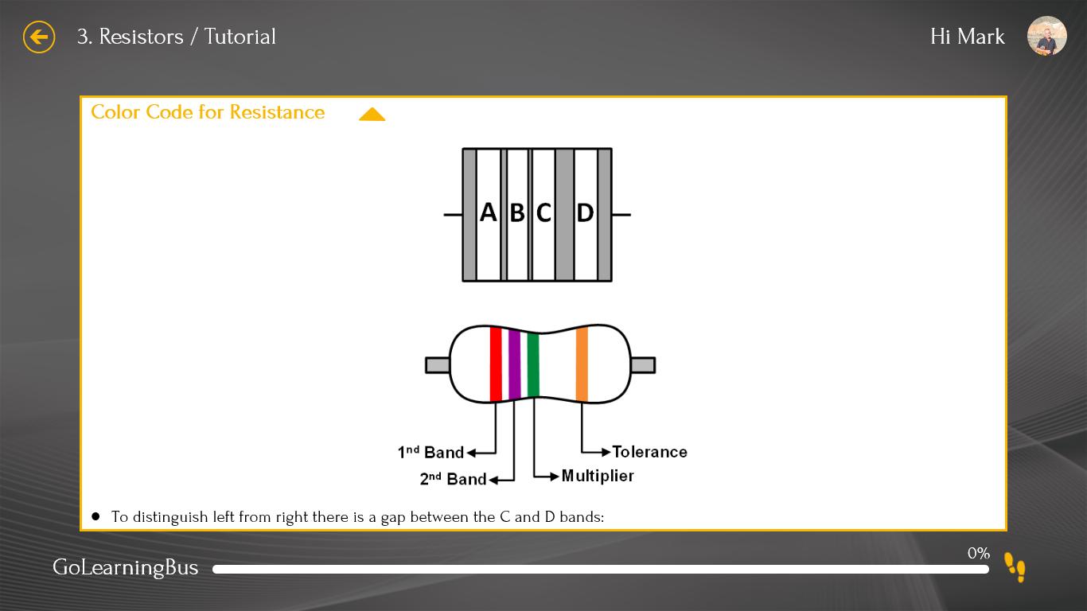
Figure 11: eLearning Resource: Colour Code for Resisters

Much of the practical content required in the electronic and maths elements of the eLearning resource was provided in Floyd (2009), the requirements to design the section of the resource that specifically dealt with the fundamentals of basic electricity and electronics. Analysis of the information gathered in the focus group interview indicated this as fundamental for acquiring further domain knowledge. They identified the following maths material required for their basic understanding of electronic to be included in the eLearning resource (a) Scientific Notation (b) Electrical Units and Metric Prefixes (c) Metric Unit Conversions (d) Measured Numbers; Significant Digits; Rounding Up-Rounding Down).

4.0 Research Design
4.1 Ethics
Access to the students in this study was obtained via a Computer and Technology lecturer in Dun Laoghaire College of Further Education. Approval was granted for the study with consent given by the Head of Department. Appropriate oversight for the conduct of research took place, and a basis for trust was established between the researcher and the study participants. Before taking part in the research, all students signed an “Informed Consent Form”, which outlined all relevant details, procedures and their rights to withdraw, including information on what the collected data would be used for; all of the students who took part were 18 years or over.
4.2 Case Study Methodology
A critical stage in conceptualising a structure for the eLearning resource was to identify and match the learning needs of the target group to the development of the resource. Early in the 1st semester, a questionnaire and class question & answer session was held with twelve students from the target user group, the findings indicated that they had limited exposure to some key electronic technologies and lacked the specific maths skill set required to understand circuit principles in electronics and electrical fundamentals. The ultimate goal of the eLearning resource was to produce effective and clear instruction to aid learning on an individual basis.
A case study methodology was the most suitable form of qualitative enquiry for the context of the study, entailing an inclusive in-depth analysis of the issues to be explored. Building an accurate profile of the “learners” helped the researcher to focus on the target audience, allowing for the development of a pedagogically sound justification for selecting and developing the eResource. Carrying out a questionnaire and class question & answer session at the pre-implementation stage allowed resource development to be aligned closely with the expressed needs of the sample population of 12 students. The findings were processed and measured against the resource aims. 1st year electronic students were keen to learn about background, opportunities and subject matter involved in electronic and green technologies.

4.3 Data Collection Methods
Post resource questionnaires and interviews were carried out with the same cohort; two did not participate, leaving n=10, with eight of the ten having participated in short semi-structured interviews. The questionnaire had 12 open ended questions and further prompts were added to these with the goal of eliciting richer responses which were targeted, authentic and accurate. The main reasons for conducting a questionnaire at the outset of the study was to explore the ideas and thoughts held by the students about the resource design, content layout, and its aims and objectives.
4.4 Preliminary Findings
The information gained as a result of the questionnaire (Table 1) specified a number of student concerns:
(A) 10 of the 12 respondents wanted the resource to contain a sizeable element covering basic electricity, and within this subject, 8 of the 12 respondents wanted particular attention on voltage drop and current flow in circuits.
(B) The Green Technology topic was to be addressed only at a preliminary level, with general comments showing interest in its employment potential; it was explained to the students that resource size and time constraints influenced this; 8 of the 12 respondents responded positively to the inclusion of the Green Technology introductory material.
(C) 11 of the 12 respondents wanted some information regarding future employment prospects in the electronic and green technology sector; to encourage engagement it was considered important to include a general introduction to this area.
(D) 7 of the 12 respondents wanted Scientific Notation content included when it was explained that a working knowledge of this is fundamental to understanding electronic component values; the remaining 5 had knowledge of scientific notation, and 3 of the 5 respondents wanted extra information on node analysis; it was deemed that due to time and resource size this was outside the scope of the eResource.
(E) 6 of the 12 respondents wanted basic electronic skills included in the eResource; the lower figure for inclusion of this material was explained because 10 of the 12 learners had some previous knowledge of basic electronics; however it was deemed essential for programme structure, coherence, revision purposes and for those with little prior learning of electronics to include it as an essential element.
(F) Further to questionnaire findings, there was a detailed discussion between the researcher and an instructional design friend on the merits of using a linear menu with drop down links to each embedded app, numerous attempts at employing these features resulted in inconsistent outcomes and the endeavour was shelved. The eventual resource design used was as a result of several iterations resulting from instructional designer, teacher and student feedback, the teacher was keen to see an autonomous, standalone resource with minimal need for extra instruction.
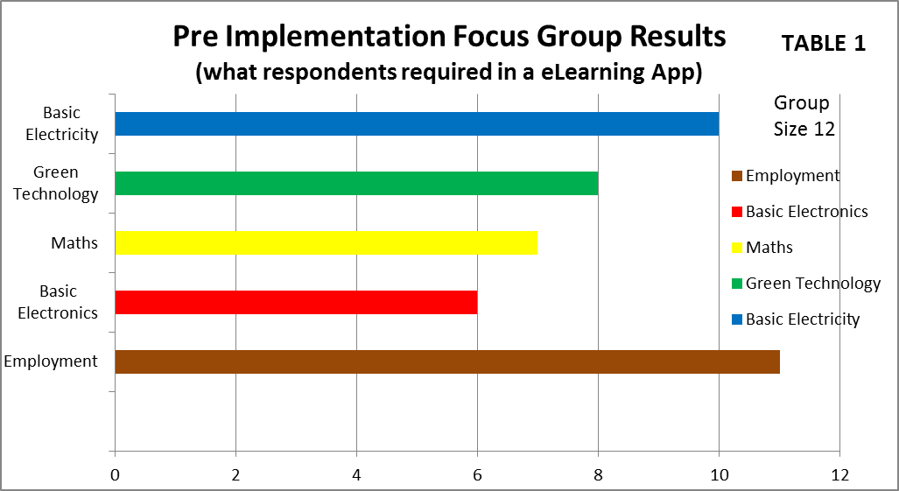

Table 1: Pre Implementation Focus Group Interview Results

Respondents Prior Academic Knowledge (Group #12) TABLE 2
Employment opportunities |  |  | 2 (16.66%) |  |  |  | 10 (83.33%)
Basic Electronics | 2 (16.66%) | 1 (8.33%) | 3 (25%) | 1 (8.33%) | 2(16.66%) | 1 (8.33%) | 2 (16.66%)
Maths for Electronics | 2 (16.66%) |  | 2 (16.66%) |  | 2 (16.66%) | 2 (16.66%) | 4 (33.33%)
Green Technology |  |  |  |  |  |  | 12 (100%)
Basic Electricity | 2 (16.66%) |  | 2 (16.66%) |  | 2 (16.66%) |  | 6 (50%)
 | City & Guilds | Microsoft Certified Solutions Associate (MCSA) | Leaving Certificate Applied Information Technology | Cisco Certification | Fetac Level 4 Award | Fetac Level 5 Award | No Knowledge

Table 2: Respondents’ Prior Academic Knowledge

The respondents considered that subject areas in which they lacked knowledge should be covered in the eResource as a primary objective; this is indicated by a degree of correlation between these subject areas in Tables 1 and 2. For example, lack of knowledge of employment opportunities is shown in Table 2 and the students’ wish to see this subject area included in the eResource is shown in Table 1; the students also emphasised a need for the resource to be used as a revision and reference tool.
4.5 Post Implementation Findings
Ten students completed the post eResource evaluation questionnaire and eight completed short interviews which expanded and elicited more information. A selection of student feedback on the eResource reports on the student experience of using it for the first time:
There was a positive consensus about using “Xtranormal”, that it was an attention grapping introduction, and some student quotes on it were “good graphics and audio”, “the robot guy was cool”, “got my attention”. There was agreement that the introduction spurred interest, helping engagement with the rest of the eResource. The graphical quality of slide 3 was commented on: “onion type layers were good”, “easy to navigate”, “good to get info in 1 slide on where everything is in resource”. Slide 4 is the first learning resource and received positive comments: “needed a site to find all these terms-explained”, “found it really easy to get around and find stuff”, “loads of electronics explained”. There were initial issues getting the apps in slides 5 and 8 to open in some browsers, especially “Chrome”, due to pop-up blockers, and trial and error resulted in the selection of Internet Explorer as the most reliable browser to host the eResource. The students were given login credentials to log into the app site; they then selected the relevant app, and the most popular comment on the apps was the ability to navigate and select whatever topic was required: “good site to get pre exam revision done”, “site had loads of information I didn’t know”, “liked flashcards for revision”, “good dip-in-dip-out resource”, “liked diagrams in magnetism and basic electricity”. The students were positive about the quizzes, giving favourable comments regarding the presentation software, ‘Articulate Quizmaker; “liked ability to pull answers into empty boxes and immediate feedback”, “could do quiz many times-until I got it right”, ”quizzes were good for revision”. The findings on green technology were less positive, with students commenting they expected more content and more links regarding job opportunities: “green tech was underwhelming”, ”would have liked links to job websites”.
There was positive feedback about the convenience of the overall delivery method: “easy to link to resource-just use url”, “once you got used to apps-it was easy to navigate”, “short-slide and tutorial size kept it interesting”. Some students had not used Internet Explorer before and had to download it to their devices to host the resource: “apps do not like chrome-picky about its browsers”; comments were also made that the content in the apps were too large for one tutorial and needed to be spread out.

5. Findings and Discussion
The findings were coded by scrutinizing recurring subjects and opinions occurring in the semi-structured questionnaire and focus group interview; these were refined using thematic analysis, with basic themes developed into organising themes and subsequently global themes as recommended by Attride-Stirling (2001) and Krueger (2003). Common positions arose in the post eResource implementation findings, and these were collated, analysed and developed into four emergent themes: (A) Student Engagement in the Design Process (B) Ease of Use (C) The role of Active Learning in an eResource (D) Effects on face-to-face learning.
5.1 Student Engagement in the Design Process
Students appreciated that their inputs from the pre-implementation stage of the study were included in the final eResource; explaining that it helped with their engagement in using the eResource. Specific content areas were identified: Scientific Notation was highlighted as important to their learning: “want to see notation in the resource, need to know this”. Content was included in the glossary at the request of students: “glad to see definitions on voltage and current”. Students enjoyed the electronic and electricity quiz layout: “liked ability to pull answers into empty boxes and immediate feedback”, “could do quiz many times-until I got it right”, ”quizzes were good for revision”.
The lack of prior knowledge outlined in the pre-implementation findings and the students’ requirement that this is addressed in the eResource, were Green Technology employment opportunities, basic electronics (specifically the areas of current flow and voltage drop), maths for electronics and basic electricity. The inclusion of these areas in the eResource as a result of both teacher and student feedback promoted a spirit of “engagement” between the students and the final eResource - this emerged as a theme from both the focus group interview and the eResource evaluation questionnaire. The students were asked if they viewed the eResource as just more extracurricular activities, and they replied that they considered it as a support rather than extra work; when asked to elaborate, they said involvement in the eResource was voluntary, and they mostly accessed it during class time.
Of the twelve students involved in the initial focus group, two did not respond to any questions in the post-implementation questionnaire; when asked about their lack of involvement in the eResource design, one responded that everything they needed would be delivered by the teacher, and he did not see much point in using external resources; the second student was absent for this class, and did not provide any feedback.
The teacher was very engaged with the eResource, and it is the researcher’s opinion that his commitment was vital in encouraging student use, especially as the majority of the students had previously experienced the State Leaving Certificate examination, and were used to a didactic and hierarchical top-down teaching and learning environment. Richmond, A. S., & Cummings, R. (2005) describe, “The Symbolic Learning Environment” In this environment, course activities include incorporation of traditional tests and lectures that focus on abstract theories and concepts
5.2 Ease of Use
Eight of the twelve respondents revealed that ease of use was a factor in their take-up of the eResource: “easy to link to resource-just use url”; the remaining four made no comment on ease of use; of the eight respondents, three had not used electronic eResources before but said they found it easy to use. When asked to explain which aspects, they responded that they specifically found the glossary and quizzes easy to use.
On the issue of whether the eResource offered any degree of flexibility for learning, students replied: “easy to use menu”, -“easy to skip to any slide”, “easy to skip to quizzes or glossary or just do apps”; it gave them the ability to dip ‘in and out’ of the content as need arose and they did not need to study the whole set of topics, but just to navigate to areas of interest. Eight of the twelve students liked the idea of a single location to access information on all subjects, responding that the content was relevant, and mirrored the discussion in the pre-implementation focus group interview. This again reinforced their satisfaction that the eResource heeded their learning needs. When asked about the coherence and sequencing of the material, there was a mixed review, with six of the twelve students replying they would have liked a main menu page at the start to simplify navigation, although they went on to say that overall this did not impede their learning.
Overall the students had positive comments with regard to usability, with the consensus being that the eResource provided a single location to access information on four key topics enabling “me to access information at my own pace from the classroom and at home" (Student A, Questionnaire).

5.3 Role of Active Learning in an eResource
The degree of active learning engaged in by the students was shown by their remarks about enjoying the quizzes as an activity and how it helped them to remember content and reflect on material covered: “could do quiz many times-until I got it right”. They found the glossary convenient for reference and reinforced terminology of which they were unsure. The use of circuits demonstrating how current flow operates was remarked on by students as being especially useful in enhancing their learning and deepening understanding of this key area: “liked diagrams in magnetism and basic electricity”.
Teacher guidance proved important at the introductory stages for the three students that had not used electronic eResources before; as they became more familiar with the concept of the eResource, they were able to navigate and use it independently. When asked if the eResource promote a degree of group work, the overall consensus was that it was used on an individual basis with little room for effective group work other than conferring in class.
Kibble (2007, pp.253-260) suggests that “Performance on online quizzes is a better predictor of student learning outcomes if they are completed voluntarily as part of formative, not summative assessment.” In a post eResource discussion, the programme teacher indicated that positive learning outcomes were achieved by those students who attempted the quizzes a number of times; this was confirmed in the follow-up student focus group interview; with students saying their quiz results became better over time and with a number of attempts. Eight of the twelve students said they were more likely to use online apps again, especially in a work context, when they needed specific information and they could find and download this information in an app; when prompted to elaborate, they said working with the app was an overall positive experience, and they liked the idea of an app they could download to a smartphone and use as they wished. Two of the twelve students did not reply, and the remaining two were of the opinion they preferred their own notes and reference material.
In terms of lab-based work, the teacher’s opinion was that the glossary was a useful resource which the students referred to when building experimental circuits (in this process the teacher lets the students work independently or in groups), helping them to better understand some of the terminology used. Adopting such a blended approach for larger cohorts can lead to improved learning outcomes and reduced costs, by replacing some of the traditional, didactic lectures with online activities that encourage active learning, such as quizzes, online discussion, tutorials, and simulations (Heterick & Twigg, 2003, cited in Garrison & Kanuka, 2004; Vaughan, 2007).
5.4 Effects on Classroom Learning
When students were asked if the eResource helped with their knowledge of specific subject areas, nine of twelve mentioned they found it very useful in for electrical and electronic theory, expressing that as they continued to use the quizzes, they found it easier to understand specific areas of this theory in the classroom setting; specifically they were referring to current flow, series and parallel circuits and voltage drop: ”loads of electronics explained”, “glad to see definitions on voltage and current”. The teacher explained that the majority of the class were more confident about finding relevant material especially on threshold concepts such as current flow, voltage drop, resistors in parallel and amplifiers than had previous cohorts preceding the introduction of the eResource.
The teacher was asked if the eResource allowed a shift from didactic teaching of foundational concepts to engaging students in advanced discussion; the reply was multi-faceted. The Teacher had not used eLearning resources in a classroom before and was not sure if they would have any discernible effect on his teaching approach. He was of the opinion that students who had used this eResource many times found it easier to understand certain threshold concepts, but that they still required a certain amount of didactic teaching to fully comprehend these concepts. He was also unsure if a certain amount of prior knowledge or better reasoning skills had influenced this result. Both students and the teacher were of the opinion that they developed prior knowledge of their programme content by engaging and completing the formative assessment tasks in the eResource. When asked if there an explicit connection between lectures and the eResource content, both students and the teacher affirmed this, with four students saying the information in the eResource on basic electricity was of help to them in reinforcing hard-to-grasp concepts, such as voltage drop and current flow. The teacher explained that these particular threshold concepts can act as roadblocks to a fundamental understanding of how circuits work, with some students grasping it quicker than others, and as a result, this can lead to a two speed learning situation, with some students forging ahead and others baffled by these concepts. He was of the opinion that the eResource helped these students, but more research would be needed to specify to what degree it aided them. Both the teacher and students agreed that having an easily accessible glossary did help to act as a bridge between basic concepts and advanced understanding. Gagne (2005) argued “the events of instruction are designed to activate the processes of information processing, or at least to parallel their occurrence and support the process.”
5.5 The role of Green Technology
The role of Green Technology in the eResource was an informative rather than a teaching issue; the opinion of the instructional designer, the researcher and the Electronics teacher at DLCFE was that five teaching resources were sufficient, alongside three quizzes. Eight of the twelve students in the focus group expressed interest in learning more about this area, and in the spirit of engagement, it was decided to include broad visions of opportunities, challenges and developments centring on domestic and international climatic concerns.
Limitations
The use of the eResource was confined to a single group of twelve, 1st year Electronic Students at Dun Laoghaire Further Education Institute; a larger research sample would have the benefit of allowing for increased perspectives and opinions. Inability to measure usage in real time, as the college Moodle site was being upgraded at that time, resulted in a lack of transparency of real time usage. The impact of the eResource on end of year exam results was not measured, as all the data was collected prior to final term exams.

6. Conclusions, Recommendations and Future Research
Feedback by questionnaires and interviews, revealed the eResource achieved the core study aim, a consensus emerged, that the novice learners had a stronger grasp of threshold concepts in electronics, electricity and maths, at their particular course stage, than previous cohorts. This must be caveated as it can take many years of experience and practice to become a competent Electronics technician with some mastering its skills and concepts quicker than others, the grades achieved in final term exams were outside the scope of the research as all data was collected prior to their publication.
Findings from this study indicate that the use of educational apps in this eLearning resource had beneficial effects on student learning, but further research must be conducted before use across programmes to ensure the pedagogical merit of selected app’s is warranted. More research is required to establish to what extent this resource helped students with acquire threshold concepts; to this end it is hoped to run the eResource again for a new cohort at DLCFE (DLFEI) in the near future, for a full year duration (by replicating this study to establish if inferences can be sustained).
Further research would be aided by the use of larger samples in further institutes of education along with analysing target group post-eResource exam results against previous groups who had no access to such a resource. In the future, the approach and strategies used in this eResource could be tailored to contexts elsewhere, and the eResource content and apps could be updated as learning technology continues to evolve. The suggested use of video and screencasts as a pre-resource technical support for future students, to introduce the resource and to discuss and resolve technical issues that may occur is open to further investigation.
The rate of growth of smartphone and tablet use amongst students is accelerating; recent statistics estimates there is now more 1.6 million apps available for Android users and Apple's App Store holds 1.5 million apps (Statistica.com. 2015), broadband speed and connectivity are constantly expanding; given this rapidly developing situation, research possibilities will arise in examining the possibilities of producing a reliable matrix to effectively measure the quality of categories of apps against pre-defined pedagogical standards. This could potentially provide future eLearning practitioners with a prefabricated tool set for measuring the effectiveness of educational apps.

Acknowledgements
The author recognises the support of Dr Roisin Donnelly (Learning, Teaching and Training Centre, DIT) during preparation of this journal.

References
A Strategy for Growth (2014-2020). Medium-Term, Economic Strategy. Dublin: Government Publications.
Ainsworth, S. (2006). DEFT: A conceptual framework for considering learning with multiple representations. Learning and Instruction, 16(3), 183-198.
Anderson, J, R. (1996). ACT: A simple theory of complex cognition. American Psychologist, Vol 51(4), Apr 1996, 355-365. Retrieved July 2015: http: //dx.doi.org/10.1037/0003-066X.51.4.355
Andrews, R., & Haythornthwaite, C. (2007). The Sage Handbook of e-Learning Research. Sage Publications.
Astin, A. W. (1985). Achieving Educational Excellence. San Francisco: Jossey-Bass.
Attride-Stirling, J. (2001). Thematic Networks: An Analytic Tool for Qualitative Research. London: Sage Publications.
Austin, K. A. (2009). Multimedia Learning: Cognitive individual differences and display design techniques predict transfer learning with multimedia learning modules. Computers & Education, Volume 53 Issue 4, December, 2009, Pages 1339-1354.
Behan, J. (2014). Occupational Employment Projections 2020. Skills and Labour Market Research Unit SOLAS.
Behan, J. McNaboe, J. Shally, C. & Burke, N. (2014). National Skills Bulletin. A Report by the Skills and Labour Market Research Unit (SLMRU) in SOLAS. Expert Group on Future Skills Needs.
Bonwell, C. & Elson, J. A. (1991). Active learning: Creating excitement in the classroom. Active Learning Workshops. Retrieved July 2015. www.active-learning-site.com
Card, S., Mackinlay, J. D, & Schneiderman, B. (1999). Readings in information visualization: Using vision to think. San Francisco, CA: Morgan Kaufman.
Chen, Y.L., Hong, Y.R., Sung, Y.T. & Chang, K.E. (2011). Efficacy of Simulation-Based Learning of Electronics Using Visualization and Manipulation. Educational Technology & Society. 14 (2), pp. 269-277.
Colaso, V., Kamal, A., Saraiya, P., North, C., McCrickard, S., & Shaffer, C. (2002). Learning and Retention in Data Structures: A Comparison of Visualization, Text, and Combined Methods. In P. Barker & S. Rebelsky (Eds.), Proceedings of EdMedia: World Conference on Educational Media and Technology 2002 (pp. 332-333). Association for the Advancement of Computing in Education (AACE)
Cousin, G. (2009). Researching learning in higher education: An introduction to contemporary methods and approaches. Routledge.
Delimarsky, D. (2011). What makes an app a good app - 7 pointers. Retrieved August 28, 2011 from http://dotnet.dzone.com/articles/what-makesapp-good-app-10).
Eivers, E. & Clerkin, A. (2011). Trends in International Mathematics and Science Study, Reading, Mathematics and Science Outcomes for Ireland. Dublin: Educational Research Centre.
Ezer, H. (2009). Self-Study Approaches and the Teacher-Inquirer. Rotterdam: Sense Publishers.
Floyd, T. L. (2009). Electronics fundamentals: circuits, devices and applications. (8th Edition). Prentice Hall.
Foreman-Peck, L., & Winch, C. (2010). Using educational research to inform practice: A practical guide to practitioner research in universities and colleges. New York: Routledge.
Forfas (2010). Future Skills Needs of Enterprise within the Green Economy in Ireland. Expert Group on Future Skills needs. Dublin 2, Ireland.
Further Education and Training Strategy (2014-2019). Solas, Further Education and Training Authority. Dublin: Department of Education & Skills.
Gagne, R. (2005). Principles of Instructional Design. Belmont CA: Thomson/Wadsworth.
Garrison, D. R., & Kanuka, H. (2004). Blended learning: Uncovering its Transformative Potential in Higher Education. Internet and Higher Education, 7, 94-105.
Gordin, D. N., & Pea, R. D. (1995). Prospects for scientific visualization as an educational technology. Educational Technology & Society, 14(2), 269-277.
Harasim, L. et al., (1995). Learning Networks. A Field Guide to teaching and learning online, MIT Press, Cambridge, Mass.
Heterick, B., & Twigg, C. (2003). The learning market space. Retrieved May 2015. http://www.thencat.org/Newsletters/Feb03.html
Huczynski, A. (2004) Influencing Within Organizations. Routledge: London, UK.
Kearsley, G., & Schneiderman, B. (1999). Engagement theory: A framework for technology based teaching and learning. Educational Technology 38(5), 20-23.
Keller, P. R., & Keller, M. M. (1993). Visual cues: Practical data visualization. Silver Spring, MD: IEEE Computer Society Press.
Kibble, J. D. (2007). Use of unsupervised online quizzes as formative assessment in a medical physiology programme: effects of incentives on student participation and performance. Advances in Physiology Education, 31(3), 253-260.
Krueger, R. A., & Casey, M. A. (2002). Designing and conducting focus group interviews. Social Analysis, Selected Tools and Techniques, 4-23.
Liang, H. N., & Sedig, K. (2010). Can interactive visualization tools engage and support pre-university Students in exploring non-trivial mathematical concepts? Computers & Education, 54(2010), 972-991.
Moore, B. (2011). Evaluating and blending multimedia mobile applications into technical training. Doctoral dissertation, University of North Texas. Retrieved April, 2012 from http://proquest.umi.com/pqdlink?did=2532396
Moore, M. G., & Kearsley, G. (1996). Distance Education: A Systems View. Belmont, CA: Wadsworth Publishing Company.
Mulder, Y. G., Lazonder, A. W., & de Jong, T. (2010). Finding Out How They Find It Out: An empirical analysis of inquiry learners’ need for support. International Journal of Science Education, 32(15), 2033-2053.
Naps, T. L., Rößling, G., Almstrum, V., Dann, W., Fleischer, R., & Hundhausen, C. (2003). Exploring the role of visualization and engagement in computer science education. ACM SIGCSE Bulletin, 35(2), 131-152.
OECD (2012), "ICT Skills and Employment: New Competences and Jobs for a Greener and Smarter Economy", OECD Digital Economy Papers, No. 198, OECD Publishing, Paris. Retrieved, January 2013. DOI: http://dx.doi.org/10.1787/5k994f3prlr5-en
OECD TALIS. (2009). Teaching and Learning International Survey. PLACE: OECD Publishing.
OpenLearn - The Open University (2011). Why sustainable energy matters - An introduction to sustainable energy. Retrieved December 2012: http://www.open.edu/openlearn/science-maths-technology/science/environmental-science/why-sustainable-energy-matters/content-section-0
Record, P. (2005). Teaching the art of fault diagnosis in electronics by a virtual learning environment. Education, IEEE Transactions on, 48(3), 375-381.
Redish, E, F. (2003). Teaching Physics with the Physics Suite CD. New York. Wiley
Richmond, A. S., & Cummings, R. (2005). Implementing Kolb’s learning styles into online distance education. International Journal of Technology in Teaching and Learning, 1(1), 45-54.
Ronen, M., & Eliahu, M. (2000). Simulation - a bridge between theory and reality: the case of electric circuits. Journal of Computer Assisted Learning, 16(1), 14-26.
Shank, P., & Bircher, J. (2009). Essential Articulate Studio ’09. Sudbury, MA: Wordware.
Statista. (2015). The Statistics Portal. Retrieved: July 2015. http://www.statista.com
Stevens, K., Gerber, D., & Hendra, R. (2010). Transformational Learning through Prior Learning Assessment. Adult Education Quarterly, 60(4), 377-404.
Thomas, G. (2013). How to do your Research Project: A Guide for Students in Education and Applied Social Sciences. London: Sage.
Tufte, E, R. (1990). Envisioning Information. Published BY Graphics Press.
Vaughan, N. (2007). Perspectives on blended learning in higher education. International Journal on E-Learning, 6(1), 81-94.
Wag Mobile Inc. (2014). Retrieved: January 2015 http://www.wagmob.com/

